**Come valutare il potenziale di localizzazione del tuo sito web?**

Tools such as Google Analytics, Zap or Piwik, all allow to see in-depth information about your website. TRANSLATED TRANSLATED These tools will help you to understand the locale specific amount of traffic, get to know the sources of your traffic and crucial information for a successful SEO optimization, keywords and phrases that are generating the most traffic.

**TRANSLATED In-depth keyword research in target markets**

With the data that you collected above, or working with your marketing team, research on the keywords that drive the traffic the most. Look for specific search patterns and trends. You can use Google keywords planner to discover valuable keywords that are frequently used.

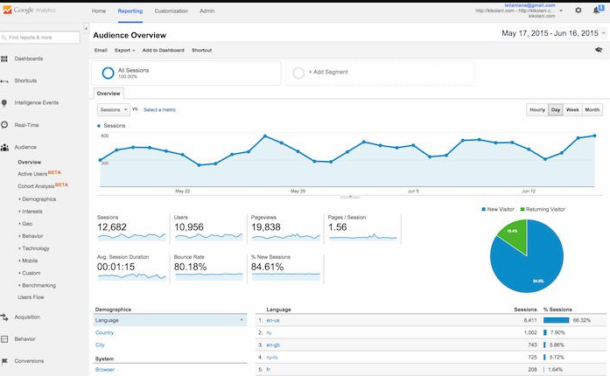

**Calculate ROI – Return of Investment**

Localization costs are based on the volume of content that you need to translate and localize. You need to carefully assess which content truly needs to be translated to which target markets.

There are many performance indicators and metrics that you can use to measure costs and returns of a localized website as opposed to a non-localized website.

<https://www.promodo.com/roi-calculator/>

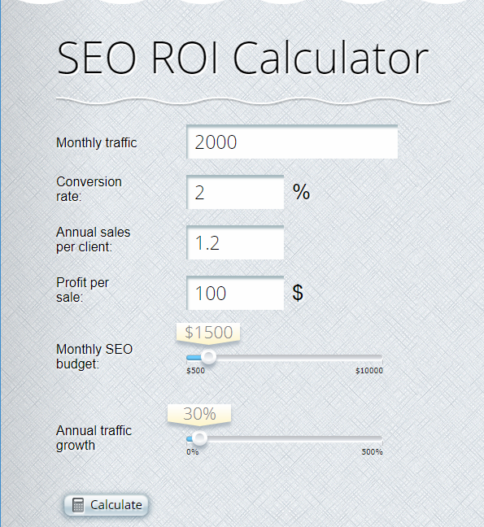

Localization decisions need to take multiple factors into considerations including the potential of target markets and existing competition in those locales. It’s extremely important to equip yourself with the right numbers and metrics that support your localization strategy. Estimating costs and returns with clear performance indicators is very helpful to assess the overall localization ROI.